CMSC 204

Huffman Lab

1. Create a Huffman Tree and generate the codes for each character of the following input:

create a huffman tree

For consistency:

1. If same frequency – put in priority queue alphabetically; put space before other characters of the same frequency
2. Add subtrees to end of group with same priority
3. Lower number has higher priority (goes to front)

1

1

|  |  |  |
| --- | --- | --- |
| Character | Frequency | Code |
| a | 3 | 110 |
| c | 1 | 000 |
| e | 4 | 111 |
| f | 2 | 100 |
| h | 1 | 001 |
| m | 1 | 0100 |
| n | 1 | 0101 |
| r | 2 | 1001 |
| t | 2 | 1010 |
| u | 1 | 011 |
| space | 3 | 1011 |

0

1

1

1

1

0

0

0

1

0

1

0

3

2

2

2

0

0

1

1

1

1

1

0

1

3

4

0

1

Now encode “create a huffman tree”

000 1001 111 110 1010 111 1011 110 1011 001 011 100 100 0100 110 0101 1011 1010 1001 111 111

1. Based on the following Huffman tree and binary sequence, what is the text

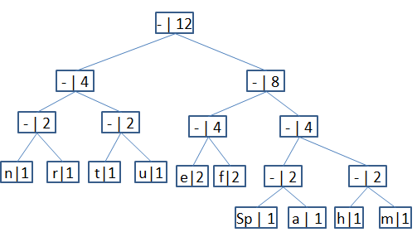

1110011101101111111010001100010001100100

Huffman tree